5th Paris Appeal Congress,
18th May, 2015, Brussels
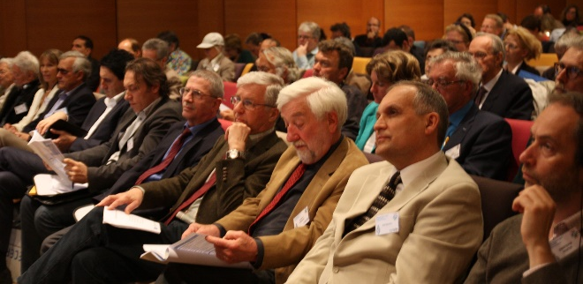

Around twenty European and North American leading experts were gathered on May 18th and 19th at the Belgian Royal Academy of Medicine, in Brussels, for the 5th Paris Appeal Congress dedicated to hypersensitivities to electromagnetic fields and to multiple chemicals.
Some 180 doctors, scientists, jurists, elected representatives, journalists and other participants coming from many countries attended this Congress, probably the most important scientific event ever organized on this topic.
Most of the speakers underlined the fact that since the 1960s, several thousand studies (1,800 between 2007 and 2012 according to the Bioinitiative report) have demonstrated the harmfulness of extended low exposures to electromagnetic fields; however, industries and governments still deny the existence of this risk, which jeopardizes the health of most living beings today, at various degrees and mostly without their knowledge.

Pr Lennart Hardell (Sweden), author of numerous publications on the links between mobile phone use and brain tumor risk, which resulted in mobile phone radiations being classified as possibly carcinogenic to humans by the WHO, reminded the audience that the electrohypersensitivity syndrome is not new. In the 1960s, the Soviets acknowledged the onset of the microwave disease during the Second World War. In 1970, a Soviet publication described the possible side effects of radars and radio sets. Close to a quarter of the military staff working with this equipment suffered from symptoms such as tiredness, dizziness, headaches, as well as concentration, memory and sleeping issues.
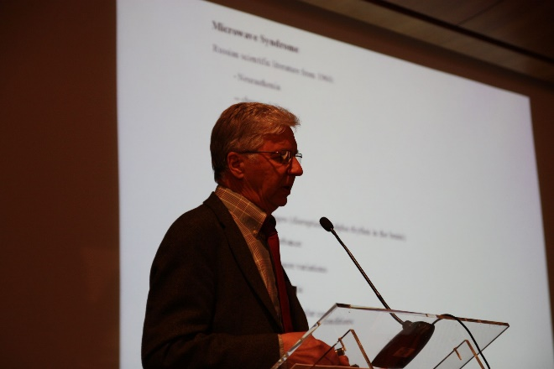
Pr Lennart Hardell stressed the major scandal of conflicts of interests around this issue. He particularly denounced the fact that the same people sit on all decision-making committees, while independent experts are systematically set aside.
Le Pr Lennart Hardell (Suède)
Pr David Carpenter (USA), the former founding dean of the School of Public Health of the University of Albany (New York), runs the Institute for Health and Environment there. An expert in the relations between diseases and exposure to chemicals and electromagnetic pollutants, he coordinated in the 1980s the New York Power Lines Project, a large-scale studies project which made it possible to confirm the higher risk of leukemia for children overexposed to high-voltage line electromagnetic fields.
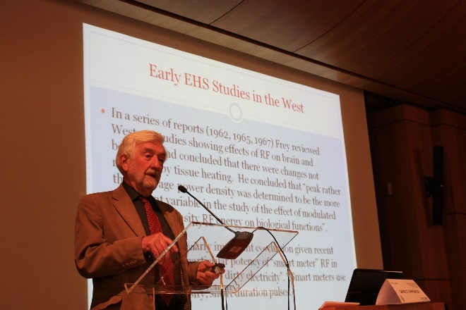
Le Pr David O. Carpenter (USA)

He is also the co-editor of the 2007 and 2012 Bioinitiative Reports, signed by about fifteen independent experts and which summarize thousands of studies on the biological effects of electromagnetic fields and recommend implementation of exposure limits based on these studies. According to Professor Carpenter, we now have proof as to the reality of electromagnetic hypersensitivity, combined with diverse unspecific symptoms that were previously related to depression.
Pr Dominique Belpomme reminded the audience that over the last four years, he had personally examined 1213 patients, 90 % of whom proved to be truly electrohypersensitive, and that he had set up a series of biological and physical objective tests. These tests have shown a hypoperfusion (decreased blood flow) of the brain and an opening of the blood brain barrier, which normally protects the brain from toxins.
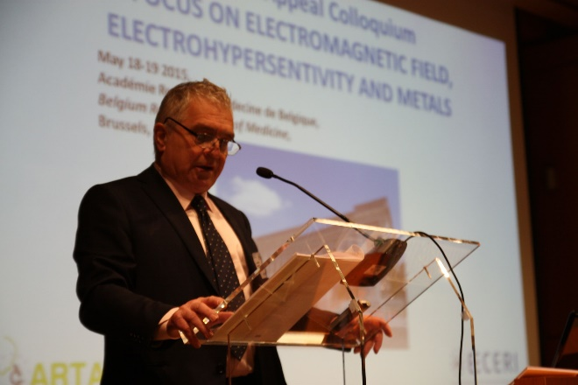
Le Pr Dominique Belpomme

Chemical and electromagnetic sensitivities are two aspects of the same disorder, sharing the same types of abnormalities in the blood and the brain. "These results need to be confirmed as part of international studies, but the scientific knowledge available to us today is sufficient for governments to recognize this disease."
Dr Ernesto Burgio (Italy), pediatrician, is the president of the scientific committee of the International Society of Doctors for the Environment (ISDE), a consultant for the WHO in the field of environmental health, a member of the scientific committee of ARTAC and ECERI, and for 10 years an epigenetic expert (study of acquired factors) in cancer and other diseases. To him, "chemical and electromagnetic sensitivity are sentinel diseases, predictive of other diseases...”
Ernesto Burgio Magda Havas William Rea Igor Belyaev
Dr Magda Havas (Canada), acting as the spokeswoman, presented the International Scientific Appeal for a better protection against exposures to EMF, initiated on May 11th of this year by 190 scientists in 39 countries. This Appeal which was widely mentioned in the international press formally demands that WHO reconsider its thresholds of protection towards populations.
Dr William Rea (USA), the former chair of cardiovascular surgery at the Veterans Hospital in Dallas and a pioneer in environmental medicine, is the founder and director of the Environmental Health Center based in Dallas. He has treated over 30,000 patients suffering from hypersensitivity to the environment and affected by degenerative chronic diseases, including hundreds of doctors who have been trained afterwards.
Among the main triggers of environmental hypersensitivities, he emphasized molds, carbon monoxide, pesticides, solvents, endocrine disruptors, heavy metals, vaccines.
Dr Igor Belyaev, an Engineer in physics and a Doctor in radiobiology, now runs the laboratory of radiobiology at the Cancer Research Institute of Slovakia. A leading expert in the field of the biological effects of EMFs, an expert for WHO, he was awarded the prize of the most determining study published between 2006 and 2010 in the journal Bioelectromagnetics. He explained that EMFs’ effects depend on a great deal of physical and biological variables that are unknown by most current studies: frequency of the expanding wave, width of the bandwidth, modulation which is the message transplanted on the expanding wave, such as music broadcasted on an AM radio station (Amplitude Modulation), individual physiological lines, and particularly physical concentration in sensors of free antioxidant radicals and divalent metals (heavy metals carriers of ions as calcium).
Other speakers stated their works related to the health effects of electromagnetic fields : Pr André Vander Vorst (Belgium), Pr Olle Johansson (Sweden), Pr Gérard Ledoigt (France). Pr Michael Kundi (Austria) highlighted how difficult it is to assess objectively the links between idiopathic environmental intolerance and exposure to EMFs and paid tribute to the important works led by ARTAC. Drs Joachim Mutter and Peter Jennrich (Germany) finally presented their clinical experimentation of the toxicity of heavy metals, particularly mercury, combined with electromagnetic fields.
To conclude this congress, an independent international workgroup was officially created, intended to have chemical and electromagnetic hypersensitivities recognized by the World Health Organization (WHO), UNO and medical Boards and included in the international classification of diseases, based on new scientific data.
Furthermore, a roundtable including scientists chaired by Mrs Michèle Rivasi discussed an international scientific statement on the existence and recognition of these affections.
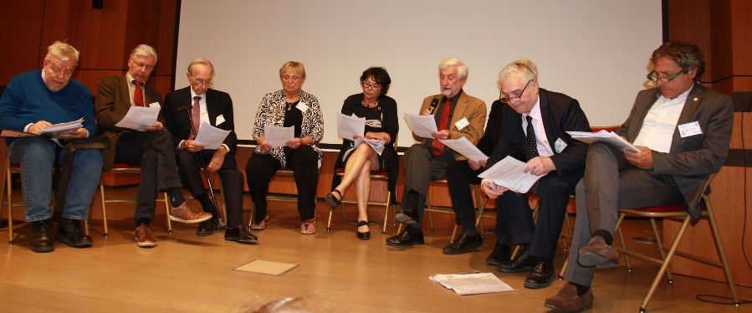
From left to right: Olle Johansson, Lennart Hardell, William Rea, Magda Havas, Michèle Rivasi, David Carpenter, Dominique Belpomme, Ernesto Burgio.

